LaCie 2TB Mobile SSD Secure External Drive (Space Gray)

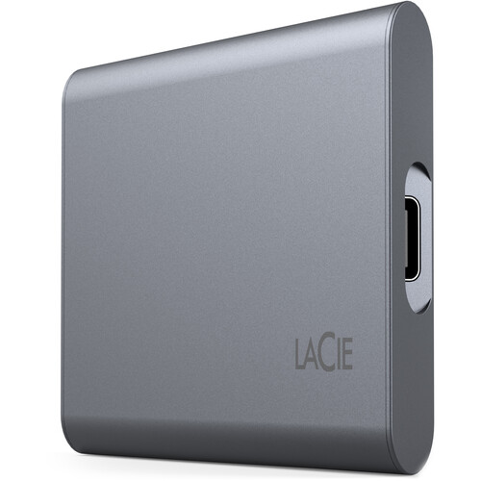

**Key Features**

* **Capacity**: 2TB storage for photos, videos, documents, and other data.
* **Performance**:
  + **Read Speeds**: Up to 540 MB/s for quick access to files.
  + **Write Speeds**: Optimized for efficient file transfers.
* **Interface**: USB 3.2 Gen 2 (USB-C) for high-speed connectivity, compatible with Thunderbolt 3 and USB-A devices (adapter included).
* **Hardware Encryption**:
  + AES 256-bit hardware encryption for secure data storage.
  + Password protection via the LaCie Toolkit software.

**Compatibility:**

* Works with Windows and macOS out of the box.
* Includes a USB-C to USB-A adapter for older devices.
* Preloaded with LaCie Toolkit software for easy data management and encryption setup.

**Warranty and Support**

* **Limited Warranty**: 3-year warranty for peace of mind.
* **Rescue Data Recovery Services**: Includes 3 years of free data recovery support in case of accidental data loss.